Najjad Zeenni’s Faculty of Engineering

Department of Computer Engineering
Computer Networks (0702551)

Client–Server Audio Recording and Transmission over TCP

Team members (Student`s ID):
Tuqa Ateeq (22112455)
Shahd Marouf (22110865)

Supervised by: Dr. Rushdi Hamamreh

Dec 6, 2025
Table of contents:

Chapter One : preface 3
Chapter Two: Introduction 3
Chapter Three: Scope 3
Chapter Four: Glossary 4
Chapter five: Functional Requirements 4
Chapter Six: Non-Functional Requirements 5
Chapter Seven: Software Tools Used 5
Chapter Eight : System Model 6
Chapter ten: System Implementation 9

Chapter One : preface
This project focuses on building a simple real-time audio communication system using C . The client records audio and sends it directly to a server over a local network, where it is received and stored. The project demonstrates basic network programming, audio processing, data transmission concepts and client–server communication.

Chapter Two: Introduction
The project presents a basic implementation of voice transmission using C. The client captures audio samples through the device microphone, stores the raw audio temporarily, and then sends it through a TCP connection to the server. The server listens for incoming connections, receives the audio stream, and stores it locally. This work highlights the essential mechanisms of real-time audio transmission and provides a foundation for more advanced systems such as VoIP applications.

Chapter Three: Scope
The scope of this project includes the following:
- Recording audio from the client device using a microphone.
- Transmitting the recorded audio to the server over a local network.
- Receiving and saving the audio file on the server side.
- Demonstrating basic client–server communication using C.

Chapter Four: Glossary
Client:
The device or application that records audio and sends it to the server.
Server:
The system that receives, stores, and manages audio files sent by the client.
Audio Stream:
A continuous flow of sound data captured during recording.
Socket:
A communication endpoint used to transfer data between the client and server.
IP Address:
A unique identifier that allows devices to communicate over a network.
TCP Protocol:
Connection-oriented protocol used for reliable transmission.

Chapter five: Functional Requirements
1. Server Functionality
- Run a TCP server and listen for client connections.
- Accept incoming TCP connections from clients.
- Receive the file size (header).
- Receive the WAV file from the client.
- Save the received file as a WAV file.
- Continue working and accept new transfers without restarting..
2. Client Functionality
- Record audio from the microphone.
- Save the recording as a WAV file.
- Allow the user to enter the server IP address.
- Establish a TCP connection with the server.
- Send the file size as a header.
- Send the WAV file to the server.
- Allow repeated recording and sending without closing the application.

Chapter Six: Non-Functional Requirements

1. Performance
- Recording should be completed with minimal latency.
- File transmission must be fast over the LAN.
- Both programs should remain responsive during recording and transmission.
2. Usability
- The application runs through terminal commands.
- Parameters such as IP address and port are clearly defined.
- Output logs show recording, saving, and sending status.
3. Reliability
- Audio must be captured and stored without data corruption.
- The server must receive the file fully and correctly.
- Programs must handle unexpected disconnections gracefully.

Chapter Seven: Software Tools Used
- C Programming Language
- GCC Compiler
- Socket Programming (sys/socket.h)
- Audio Capture (ALSA on Linux / WinAPI on Windows)
- TCP/IP Networking
- VMware Workstation
  - Windows Server (Server side)
  - Windows 10 (Client side)

Chapter Eight : System Model

8.1 Use Case Diagram:
The use case diagram for this chat application illustrates the interactions between the primary actors—Client and Server—and their corresponding functionalities. It highlights the key actions performed:
Client:
- Enter Server IP.
- Record Audio.
- Stop Recording.
- Send Audio File.
Server:
- Listen for Connection.
- Receive Audio File.
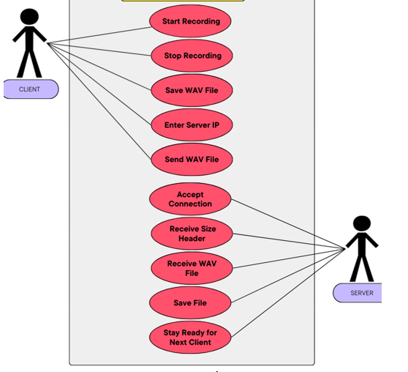
- Save Audio Fil
Figure 1 - Use Case Diagram
Chapter Nine: Sequence Diagram:
This sequence diagram shows how the Client and Server interact to record, send, and save an audio file using socket programming. The actors/components involved are:

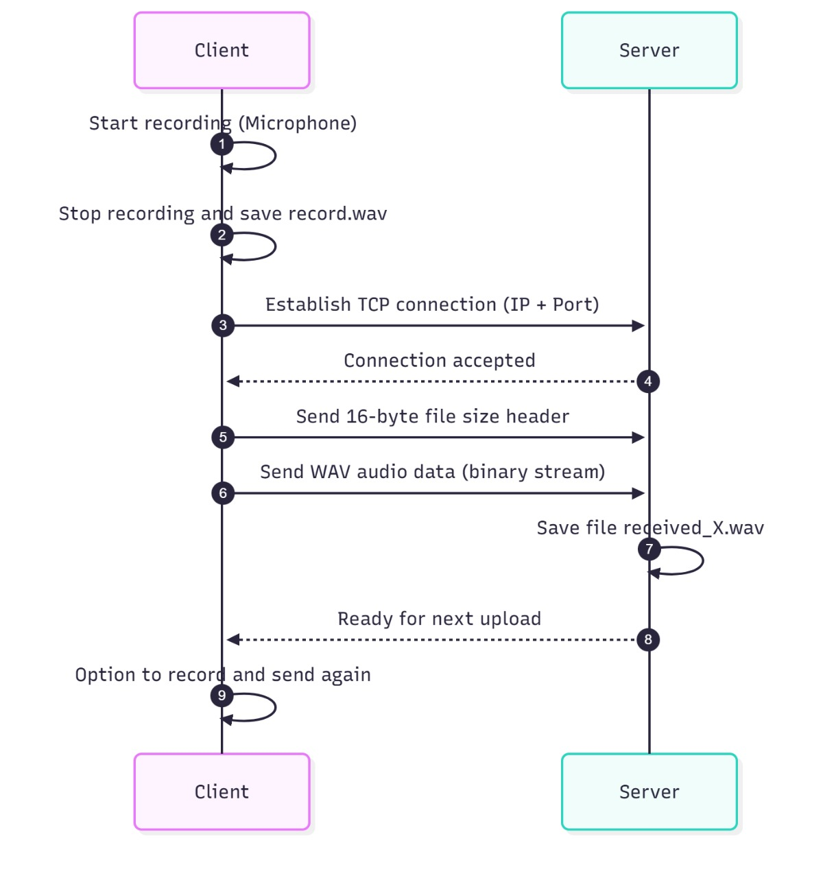

Figure - 2Sequence Diagram

Chapter Ten: System Implementation
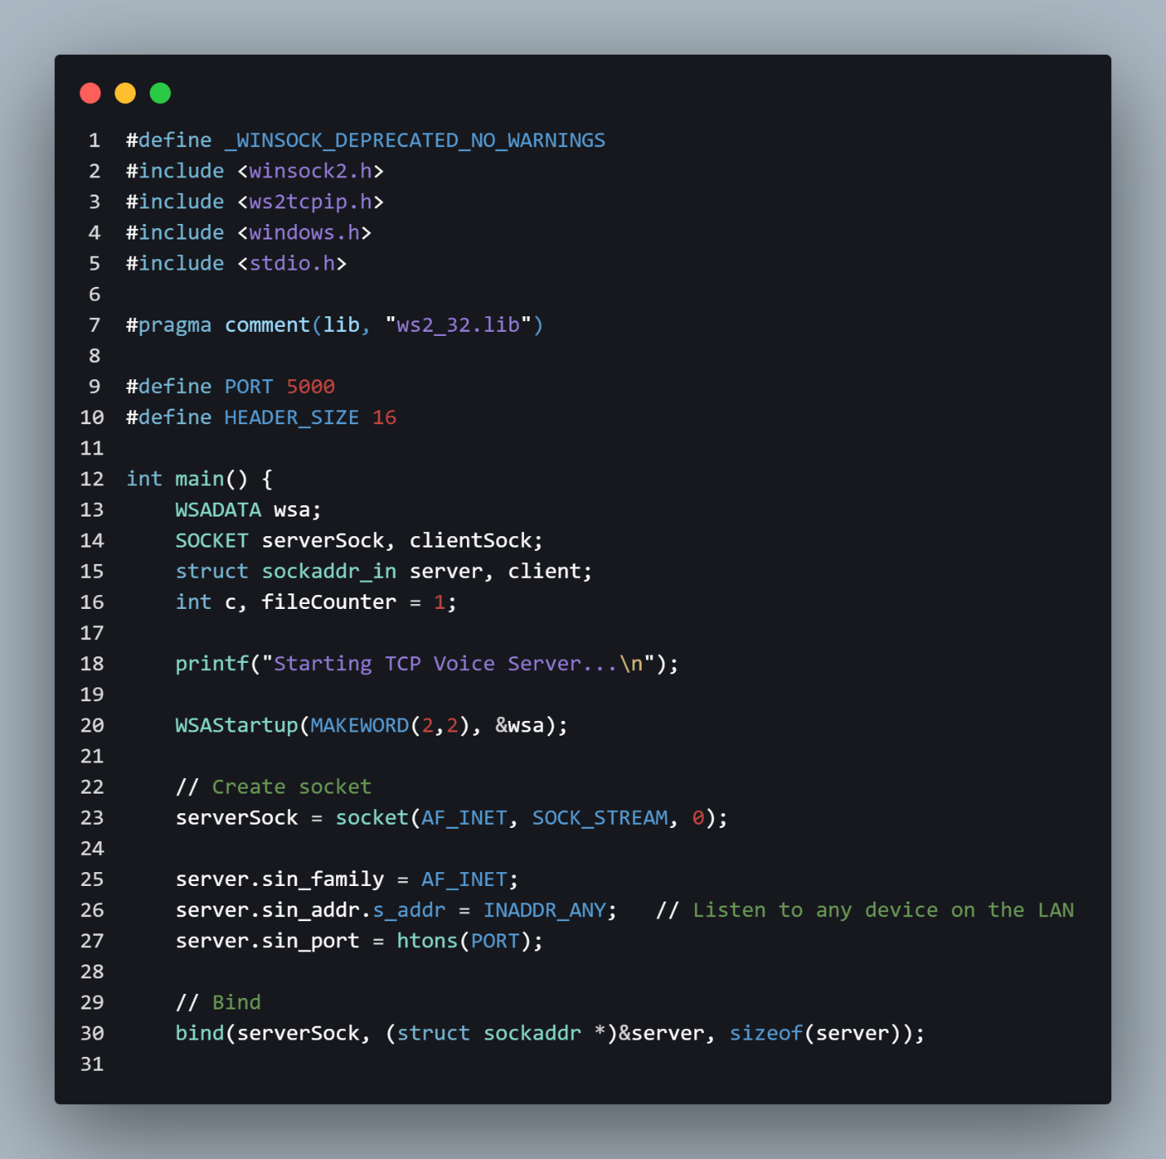
Figure 3- the server's code

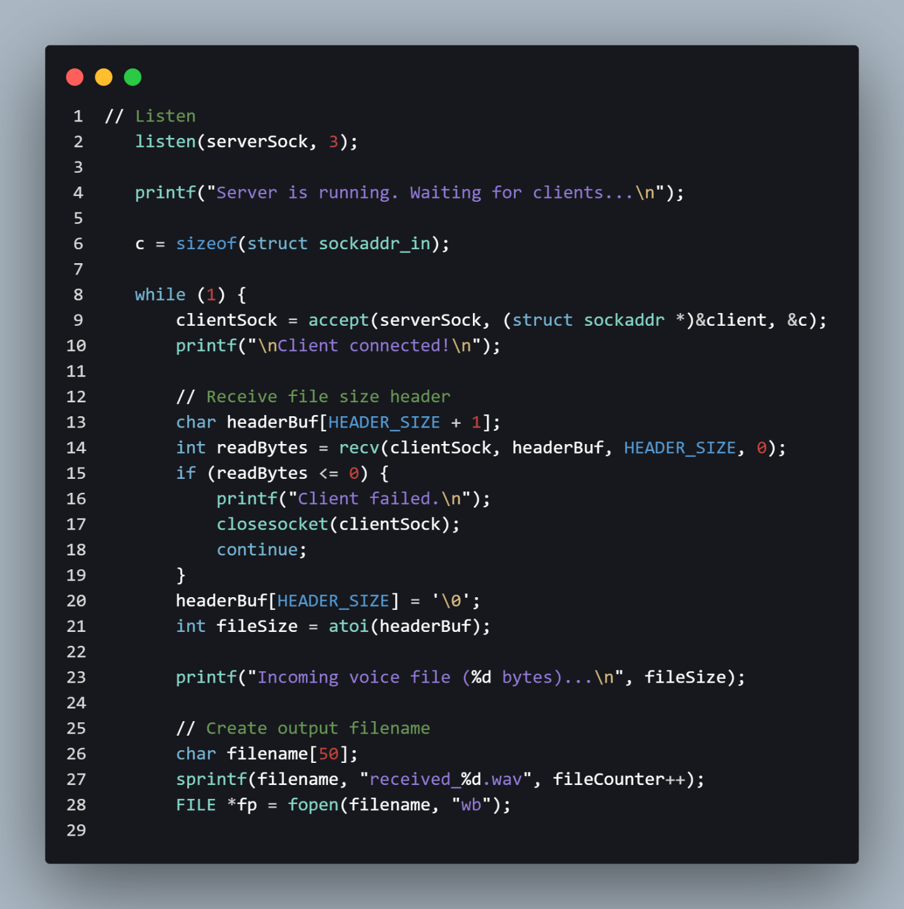
Figure 4 - the server's code

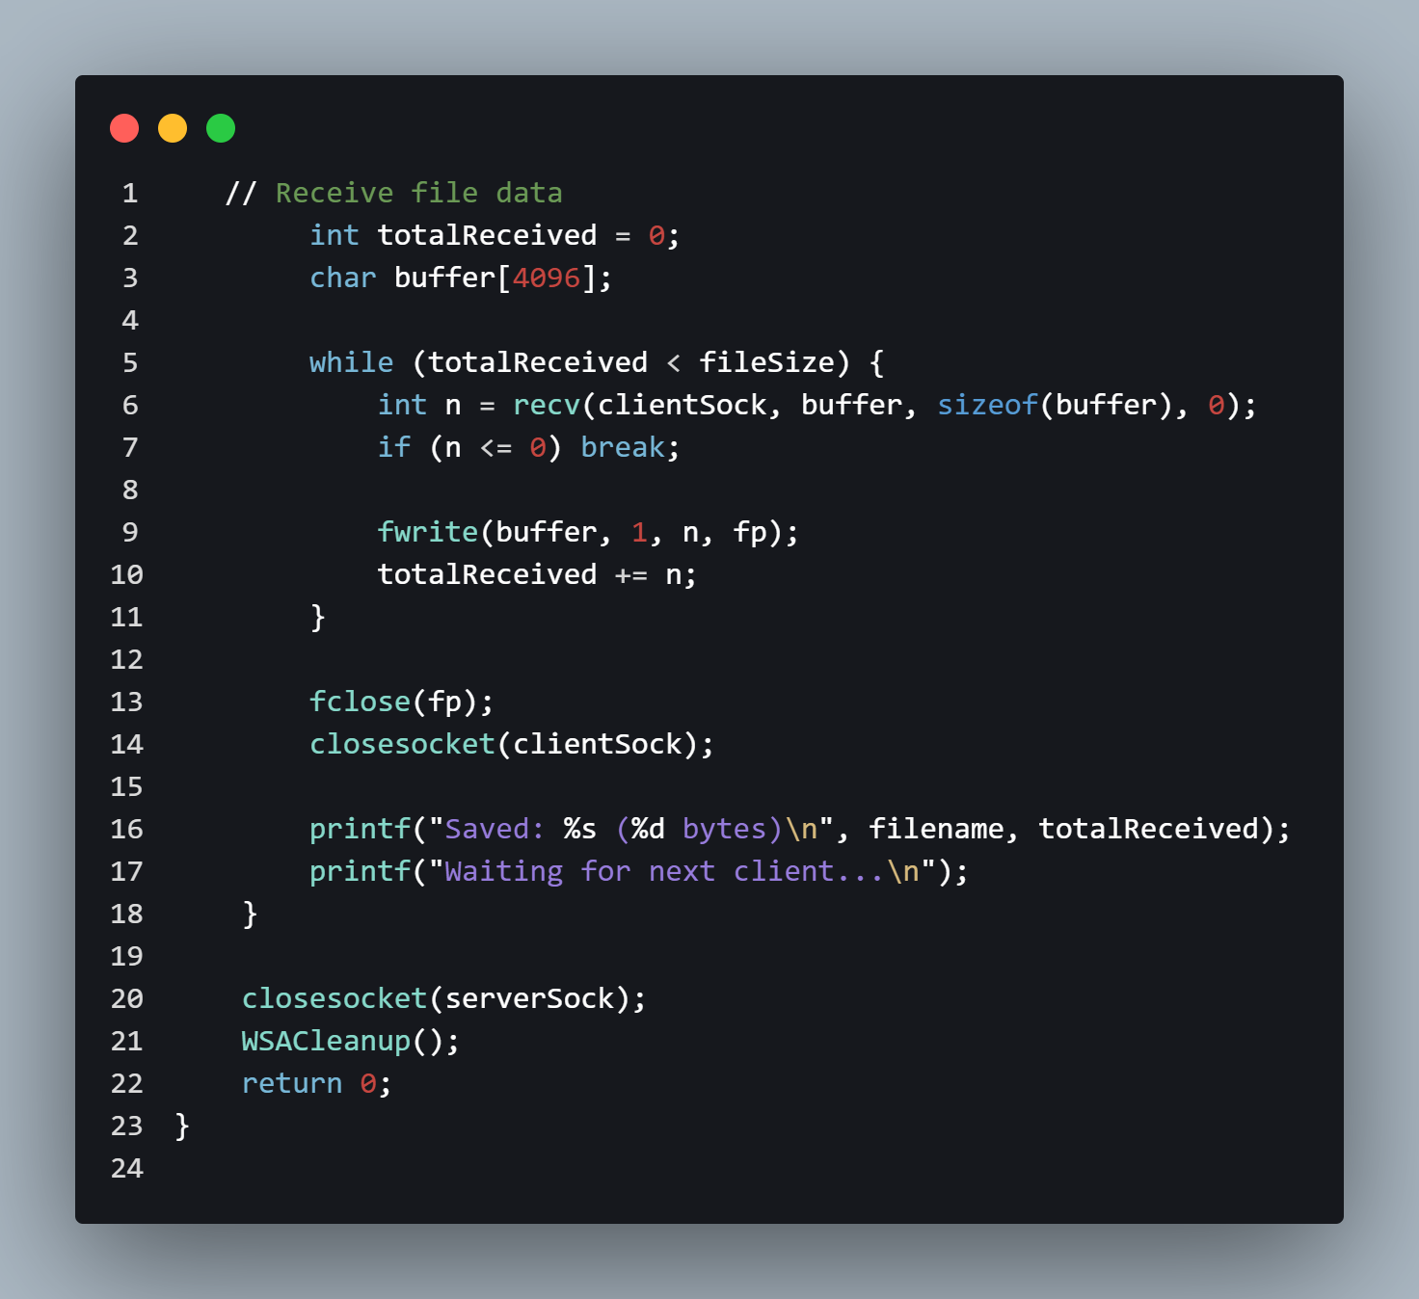
Figure 5 - the server's code

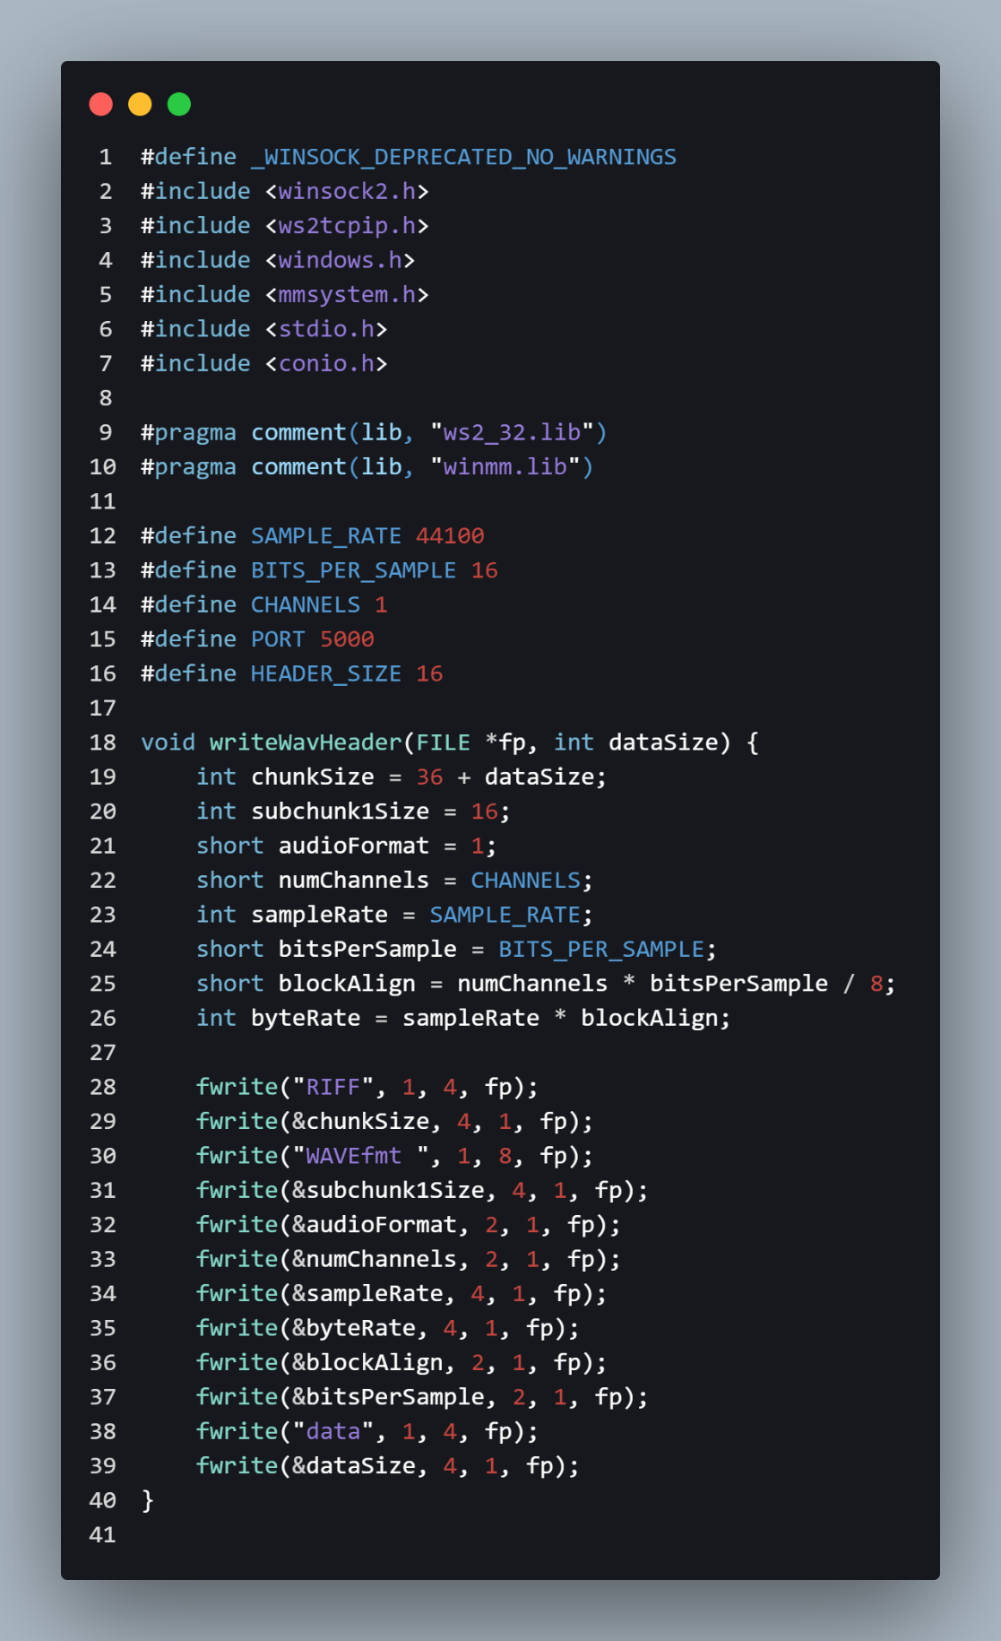
Figure 6- Client's code

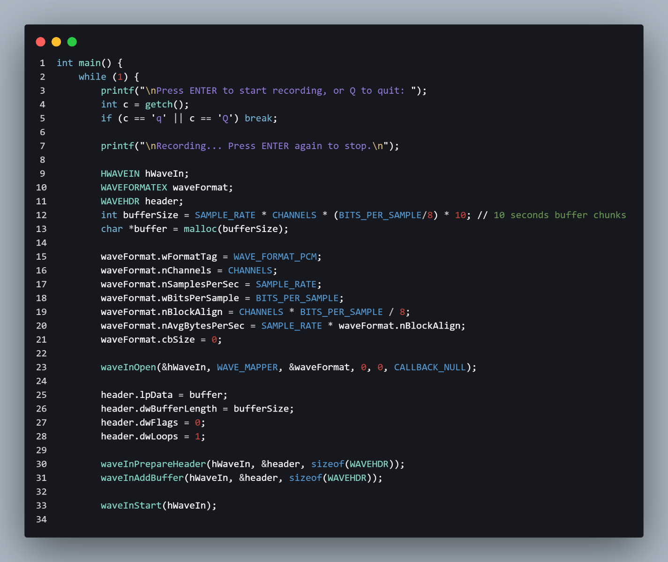
Figure 7- client's code

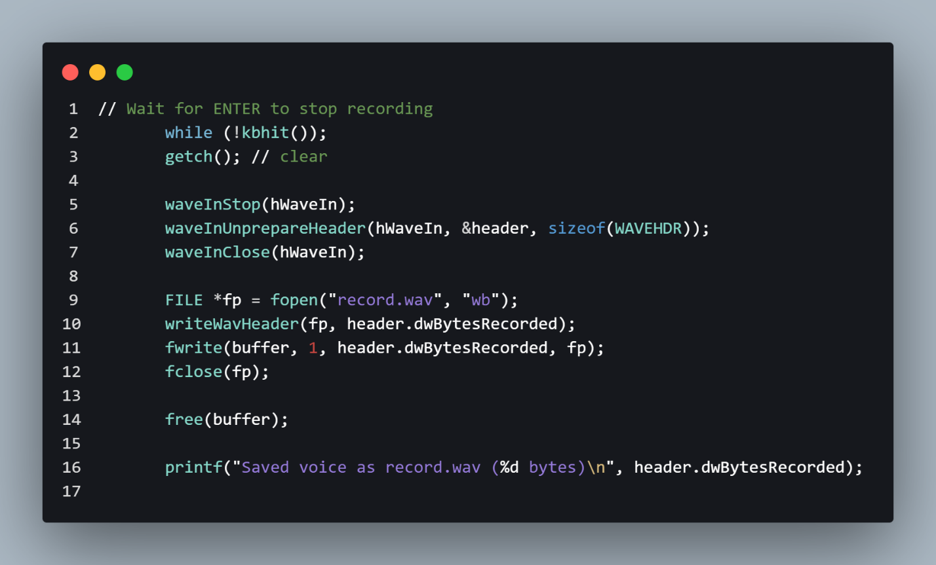Figure 8 - clien'ts code

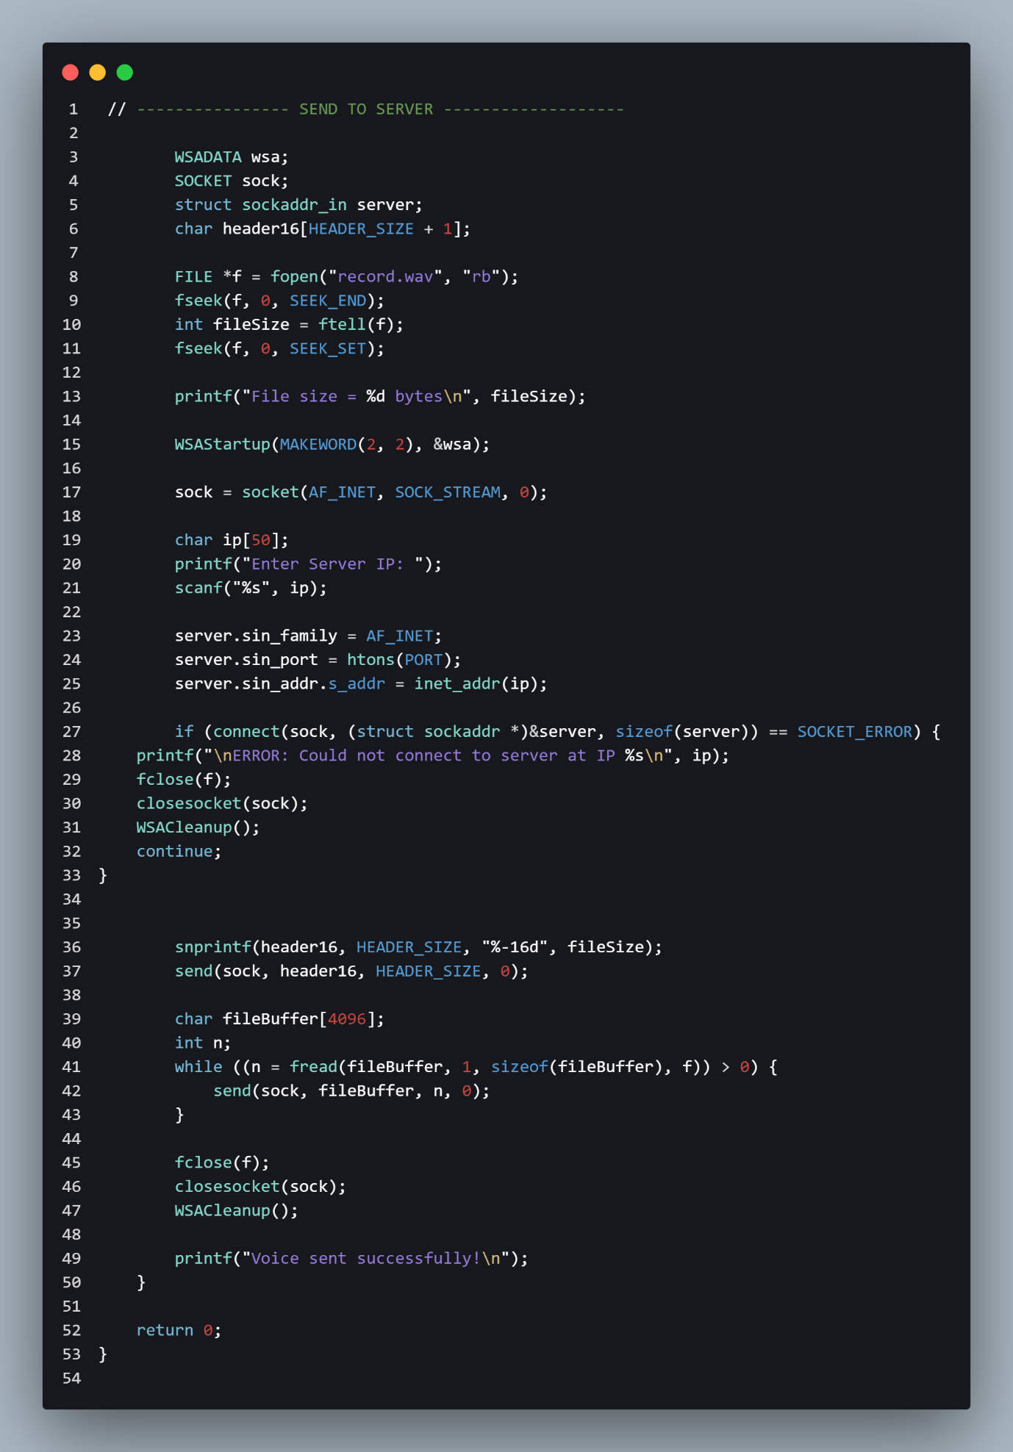
Figure 9 - client's code

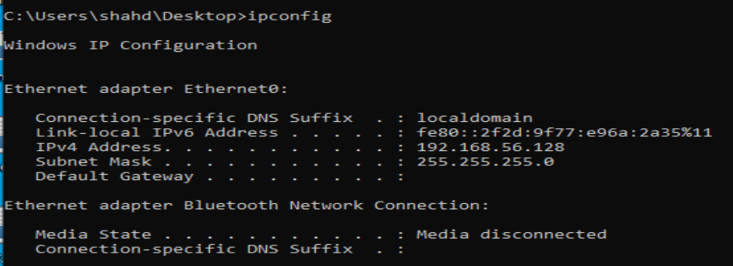
Figure 10- testing the ping between client and server

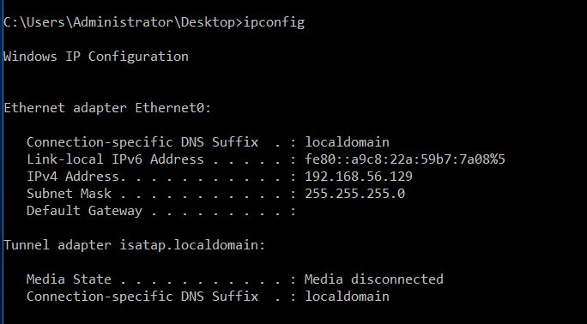
Figure 11- testing the ping between server and client

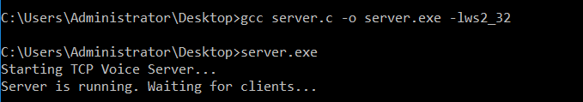
Figure 12- server program running and waiting for client connection

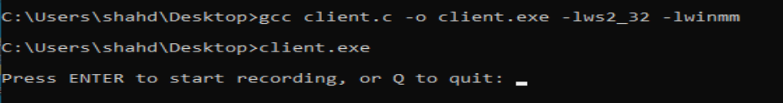
Figure 13- Client program ready to record audio

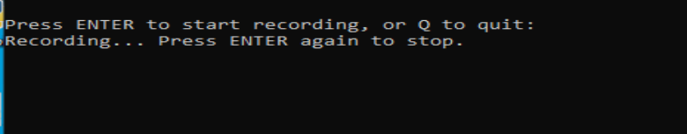
Figure 14– client strart recording

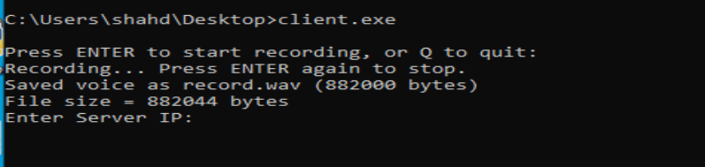
Figure 15 – client finish recording

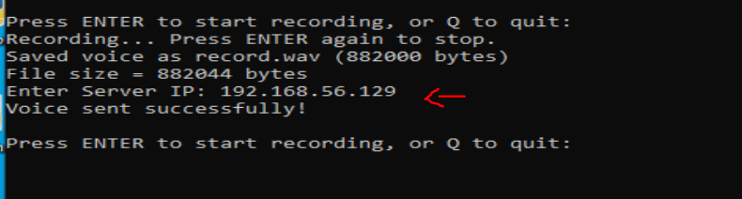
Figure 16- the client enters the server's IP

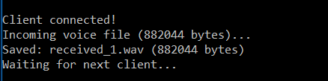
Figure 17- the client responds

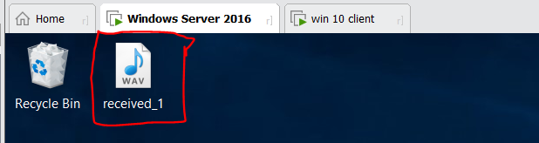
Figure 18 - storing the audio file

